**Applications:**

Our project aims to develop a web-based application for resume screening. The purpose of this application is to streamline the hiring process by automating the initial screening of resumes submitted by job applicants. Our website will utilize advanced algorithms and machine learning techniques to assist employers in efficiently filtering resumes and identifying the most suitable candidates for further evaluation.

**Key Features:**

**Resume Submission:**

Job seekers can upload their resumes in various formats (PDF, Word, plain text).

The application will handle different file types and extract relevant information.

**Resume Parsing and Extraction:**

Implement a resume parsing module to extract key details like contact information, education, work experience, and skills.

Utilize natural language processing (NLP) techniques for comprehensive resume analysis.

**Keyword Matching and Filtering:**

Create a database of keywords and job-specific criteria to match against resumes.

Develop an algorithm to score and rank resumes based on the relevance of keywords and criteria.

**Resume Evaluation and Ranking:**

Employ machine learning algorithms to analyze resumes and assess candidate qualifications.

Implement a ranking system to prioritize resumes based on their suitability for the job.

**User Interface and Dashboard:**

Design an intuitive and user-friendly interface for employers to navigate and interact with the application.

Provide a dashboard displaying summary statistics, including the number of resumes received and shortlisted candidates.

**Communication and Collaboration:**

Enable direct communication between employers and applicants through the application.

Allow employers to share candidate profiles and evaluation results with team members.

**Reporting and Analytics:**

Generate reports and analytics on various aspects, such as the number of applications received and the percentage of qualified candidates.

Provide insights to help employers optimize their recruitment process.

**Conclusion:**

Our resume screening website will revolutionize the hiring process, saving time and effort for employers while ensuring fair and efficient evaluation of applicants. By automating the initial screening stage, this application will help organizations identify the most suitable candidates for further consideration and interviews. We are committed to delivering a plagiarism-free project that meets the specific needs of resume screening in the most effective and user-friendly manner.

**Future Scope:**

**Integration with Job Portals:**

Explore partnerships and collaborations with popular job portals to integrate the resume screening application.

Enable seamless import of resumes and job postings from job portals to streamline the screening process.

**Enhanced Machine Learning Algorithms:**

Continuously invest in research and development to improve the machine learning algorithms used for resume screening.

Incorporate advanced techniques like deep learning and neural networks to extract nuanced information and improve matching accuracy.

**Natural Language Processing Advancements:**

Stay abreast of the latest advancements in natural language processing and implement them in the resume parsing and extraction module.

Leverage sentiment analysis and entity recognition to gain insights into candidates' soft skills and personality traits.

**Automated Candidate Ranking:**

Further enhance the automated ranking system by incorporating additional factors such as candidate achievements, certifications, and industry-specific knowledge.

Implement machine learning models that self-learn and adapt based on feedback from employers to continually refine the ranking algorithms.

**Skill Gap Analysis:**

Develop an advanced skill gap analysis module that assesses the disparity between job requirements and candidate skills.

Provide personalized recommendations for upskilling or professional development to help candidates bridge the gap.

**Integration with Applicant Tracking Systems (ATS):**

Collaborate with popular applicant tracking system providers to establish seamless integration with the resume screening application.

Enable bidirectional data transfer to facilitate a synchronized and efficient recruitment workflow.

**Advanced Reporting and Analytics:**

Enhance the reporting and analytics module to provide in-depth insights into the hiring process.

Generate visualizations, trend analysis, and predictive analytics to identify patterns, optimize recruitment strategies, and forecast future hiring needs.

**Multilingual Support:**

Expand the language capabilities of the application to support resumes in multiple languages.

Develop language-specific parsing and keyword matching algorithms to cater to a diverse global user base.

**Candidate Feedback and Engagement:**

Implement interactive features that encourage candidates to provide feedback on their experience with the application and the screening process.

Introduce features like application status updates and personalized notifications to keep candidates engaged and informed.

**Mobile Application:**

Develop a mobile application version of the resume screening platform to enhance accessibility and convenience for employers and job seekers.

Ensure seamless synchronization between the web and mobile platforms to provide a consistent user experience.

By proactively incorporating these future scope elements, we can continuously improve and expand the resume screening application, ensuring its long-term relevance and effectiveness in the dynamic landscape of recruitment and hiring processes.

**Bibiliography & Appendix:**

**Sources we used:**

**Code Snippets:**

**Resume_Parser :**

from pyresparser import ResumeParser

import smtplib

# SMTP initialization for Outlook

s = smtplib.SMTP('smtp.office365.com', 587)

s.starttls()

s.login("autoResumeResponse@outlook.com", "Masu6bhat@")

SUBJECT = "Interview Call"

python_skills = ["ml", "ai", "matplotlib", "seaborn",

"python", "regression", "algorithms",

"pandas", "data analysis", "keras",

"tensorflow", "artificial intelligence",

"data visualization", "opencv"]

java_skills = ["java", "object-oriented programming",

"data structures", "algorithms",

"spring framework", "hibernate",

"SQL", "multithreading", "JavaFX",

"RESTful API", "Maven", "JUnit", "JSP",

"Servlets", "OOP"]

data_Scientist = ["Machine Learning (ML)", "Deep Learning (DL)",

"Data Mining", "Statistical Analysis",

"Data Visualization", "Natural Language Processing (NLP)",

"Big Data", "Predictive Modeling", "Feature Engineering",

"Regression Analysis", "Classification Algorithms",

"Clustering Algorithms", "Time Series Analysis",

"Dimensionality Reduction", "Ensemble Methods", "Neural Networks",

"Python for Data Science", "R Programming", "SQL", "Tableau",

"Apache Spark", "Hadoop"]

def extract_skills(filename):

data = ResumeParser(filename).get_extracted_data()

name = data['name']

email = data['email']

skills = data['skills']

actual_skills = [i.lower() for i in skills]

return name, email, actual_skills

def extract_education(filename):

data = ResumeParser(filename).get_extracted_data()

education = []

if 'education' in data:

education = data['education']

return education

def extract_certificates(filename):

data = ResumeParser(filename).get_extracted_data()

certificates = []

if 'certificate' in data:

certificates = data['certificate']

return certificates

def compare_skills(appliedJob, skills):

skills_matched = []

if appliedJob == "AI/ML Dev":

for ele in skills:

if ele in python_skills:

skills_matched.append(ele)

if appliedJob == "Java Dev":

for ele in skills:

if ele in java_skills:

skills_matched.append(ele)

if appliedJob == "Data Scientist":

for ele in skills:

if ele in data_Scientist:

skills_matched.append(ele)

return skills_matched

def send_email(email, name, is_rejected, appliedJob):

if is_rejected:

TEXT = f"Hello {name}, \n\nThanks for applying to the job post {appliedJob} . Your candidature is " \

f"rejected.\n\n\n\nThanks and Regards,\n\nTalent Acquisition Team,\n\nSmartInternz by Smartbridge"

else:

TEXT = f"Hello {name}, \n\nThanks for applying to the job post {appliedJob}. Your skills match our " \

f"requirements. Kindly let us know the available time for the initial round of " \

f"interview.\n\n\n\nThanks and Regards,\n\nTalent Acquisition Team,\n\nSmartInternz by Smartbridge"

message = 'Subject: {}\n\n{}'.format(SUBJECT, TEXT)

s.sendmail("autoResumeResponse@outlook.com", email, message)

s.quit()

**From the App:**

from flask import Flask, render_template, request

from werkzeug.utils import secure_filename

from Resume_parser import extract_skills, compare_skills, send_email, extract_education, extract_certificates

app = Flask(__name__)

@app.route('/')

def homepage():

return render_template('home.html')

@app.route('/apply_job')

def applyjob():

return render_template("apply_job.html")

@app.route('/aboutUs')

def aboutUs():

return render_template("aboutUs.html")

@app.route('/fill_form')

def fillform():

return render_template("form.html")

@app.route('/uploader', methods=['GET', 'POST'])

def upload_file():

if request.method == 'POST':

appliedJob = request.form['job'] # get selected job from the form

nameGiven = request.form['name'] # get name from the form

emailGiven = request.form['email'] # get email from the form

f = request.files['file'] # taking reume file from submitted form

f.save(secure_filename(f.filename))

name, email, skills = extract_skills(f.filename)

skills_matched = compare_skills(appliedJob, skills)

# education = extract_education(f.filename)

# certificate = extract_certificates(f.filename)

# print(education)

# print(certificate)

print(email)

print(skills)

print(skills_matched)

is_rejected = True

if len(skills_matched) >= 4:

print("he is eligible")

is_rejected = False

send_email(email, name, is_rejected, appliedJob)

return render_template('success.html', name=nameGiven, email=emailGiven, skills=skills_matched)

else:

is_rejected = True

print("Sorry, we can't process your candidature")

send_email(email, name, is_rejected, appliedJob)

return render_template('success.html', name=nameGiven, email=emailGiven, skills=skills_matched)

else:

return render_template('home.html')

@app.route('/home')

def homepage2():

return render_template('home.html')

if __name__ == '__main__':

app.run(debug=True)

**Data Samples:**

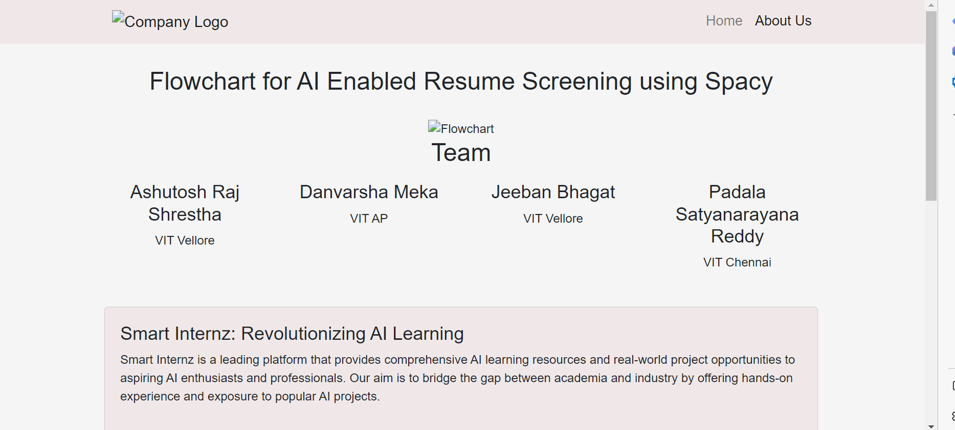

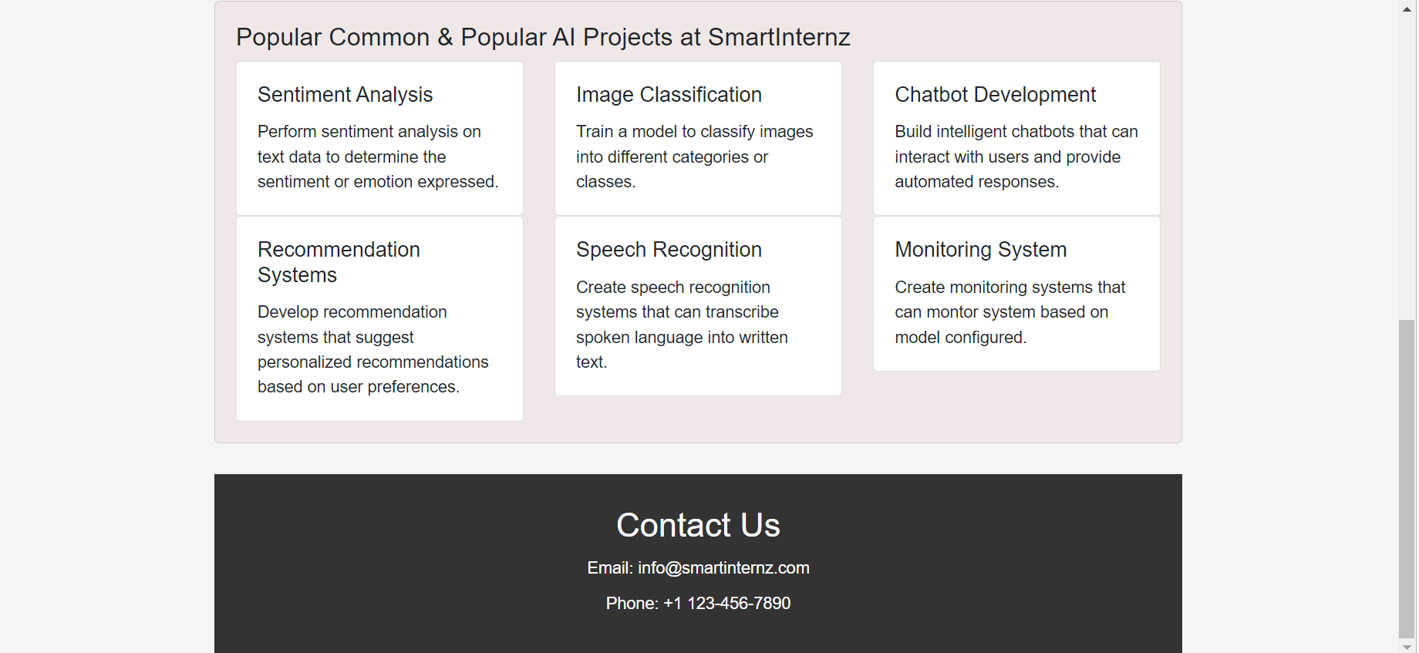

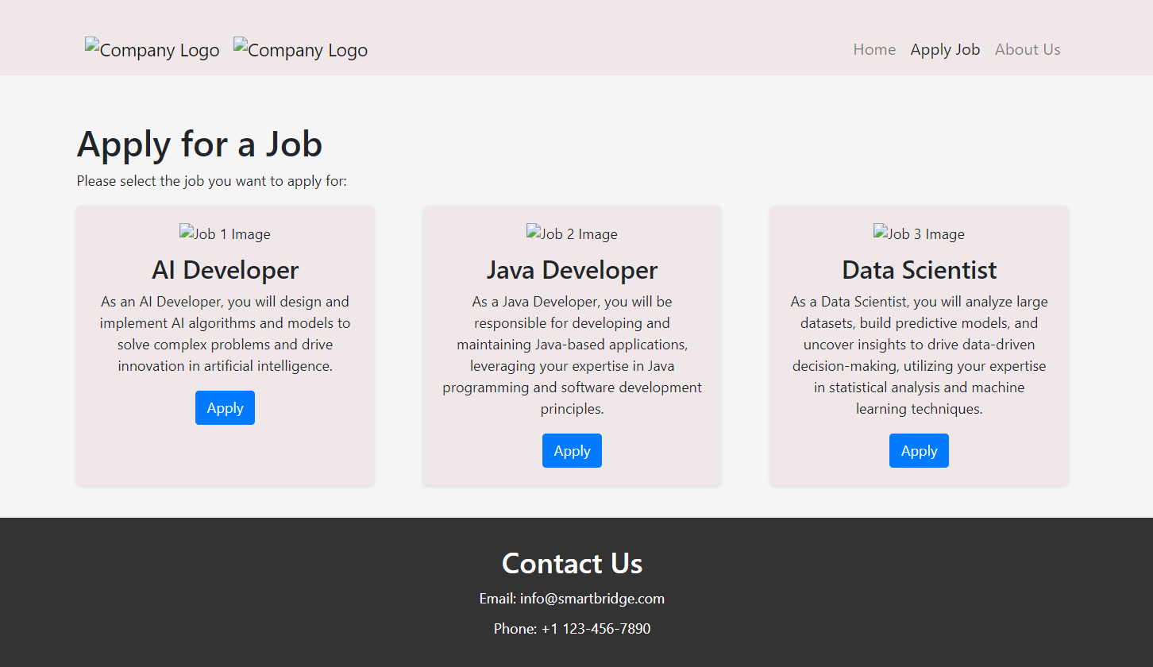

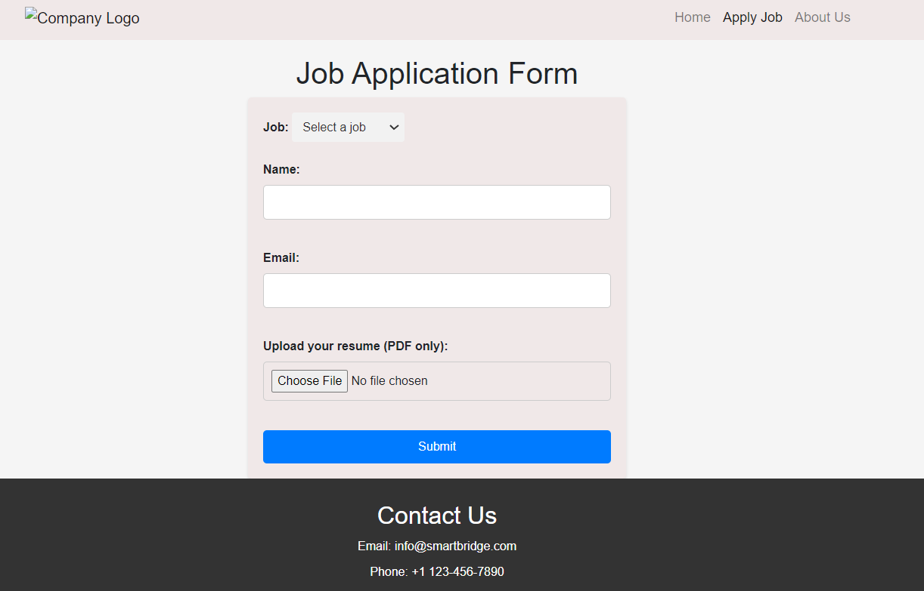

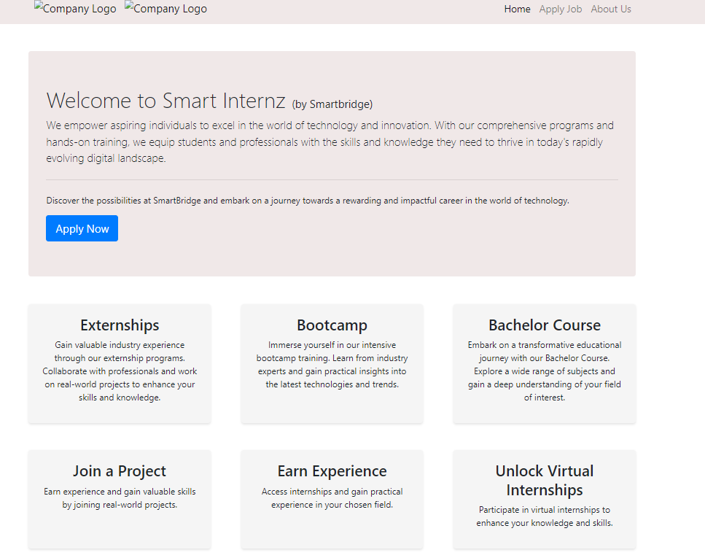

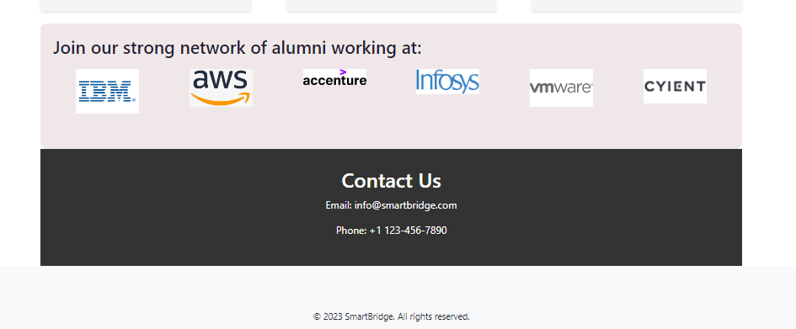

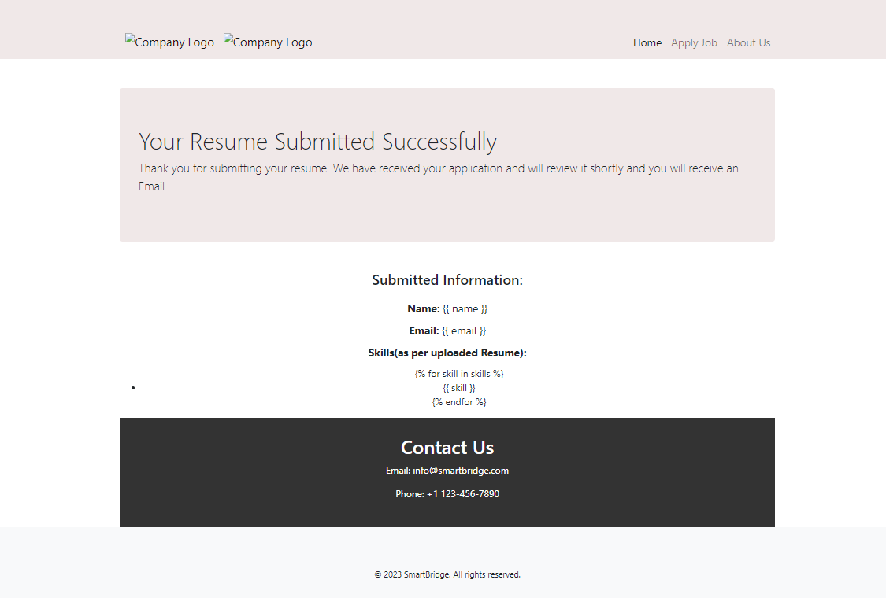

**References:**

<https://towardsdatascience.com/resume-screening-with-python-1dea360be49b>